Project Data folio and Dashboard

Name: Raneem Aqel
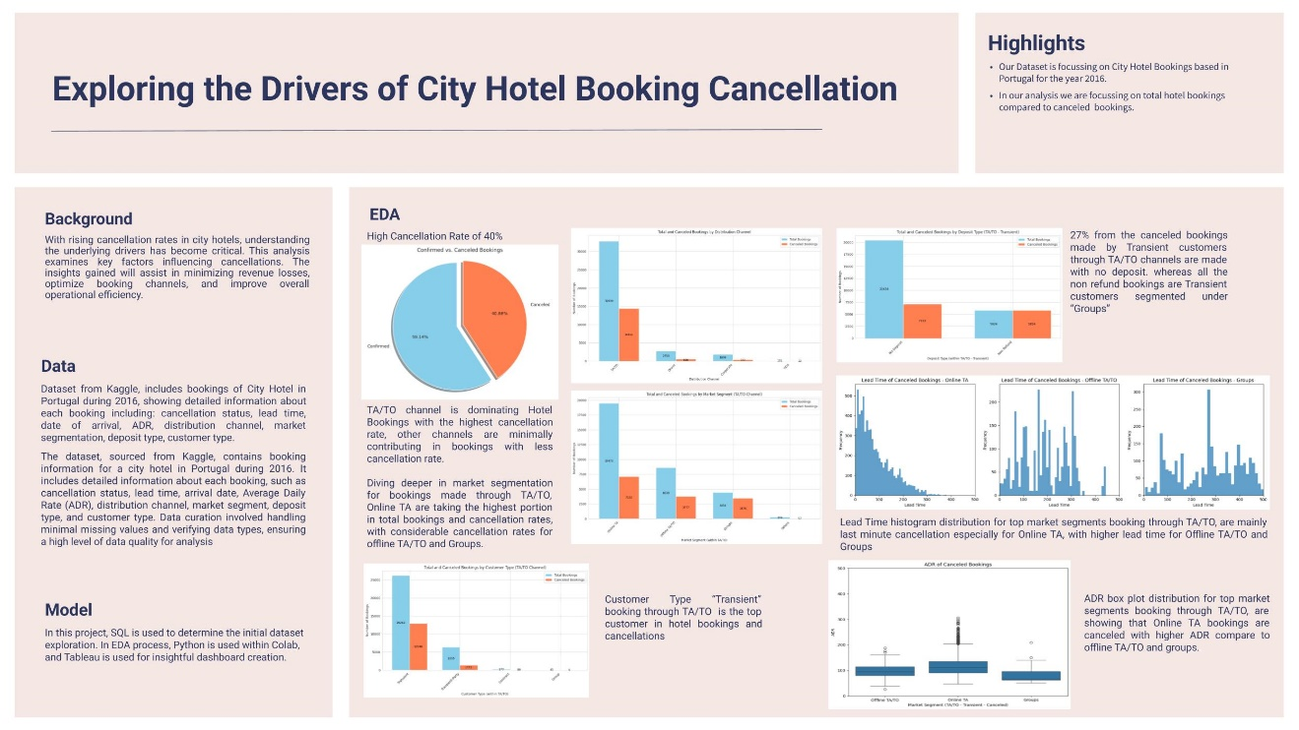

Dashboard Link
https://public.tableau.com/views/HotelBookings_17379839597110/HotelBookingsAnalysis?:language=en-US&publish=yes&:sid=&:redirect=auth&:display_count=n&:origin=viz_share_link

